MATRICES QUESTIONS

1a) Use matrices to solve the simultaneous equations 4x + 2y = 8 and
2x - 3y = 12. [3]
b) Find the matrix which carries out a reflection in the y axis followed by an anticlockwise rotation about the origin of 45º. [4]
c) Find the matrix which maps $\left(\begin{matrix}1 \\ 3\end{matrix}\right)$onto $\left(\begin{matrix}5 \\ 0\end{matrix}\right)$and $\left(\begin{matrix}2 \\ 2\end{matrix}\right)$onto $\left(\begin{matrix}6 \\ 4\end{matrix}\right)$. [4]
d) If $A=\left(\begin{matrix}3 & −1 \\ 2 & −2\end{matrix}\right)$ find the values of m and n such that A² = mA + nI, where I is the identity matrix. [4]
e) Find the inverse of $\left(\begin{matrix}1 & 2 & 3 \\ 1 & 1 & 2 \\ 1 & 1 & 0\end{matrix}\right)$. [5]

2)
a) Given $A=\left(\begin{matrix}3 & 7 \\ 2 & 4\end{matrix}\right)$ and $B=\left(\begin{matrix}1 & −2 \\ 3 & 5\end{matrix}\right)$, find A^{T}, detB, AB and B⁻¹. [5]
b) Find the 2x2 matrix which represents an anticlockwise rotation through an angle θ about the origin followed by a reflection in the x axis. [4]
c) Find the 2x2 matrix, M, which transforms the point (1,0) to (1,1) and the point (1,1) to (1,2). What type of transformation does M represent?[5]
d) Find the inverse of $\left(\begin{matrix}1 & −1 & 3 \\ 2 & 0 & 4 \\ 6 & −2 & \text{22}\end{matrix}\right)$. [6]

3) Find ${\left[\begin{matrix}−3 & −7 \\ 1 & 2\end{matrix}\right]}^{3}$. [5]

4)
a) Find the inverse of the matrix $\left[\begin{matrix}1 & −2 \\ 2 & 4\end{matrix}\right]$. Hence solve the simultaneous equations $x−2y=5$ and $2x+4y=2$. [4]
b) The triangle defined by the points $(1,0)$, $(2,0)$ and $(1,2)$ is transformed by the matrix $\left[\begin{matrix}3 & 2 \\ 2 & 5\end{matrix}\right]$. Find the area of the transformed triangle. [4]
c) If $A=\left[\begin{matrix}1 & 3 & 2 \\ 2 & 0 & −1 \\ 1 & 1 & 0\end{matrix}\right]$, then $A^{−1}=\frac{1}{2}\left[\begin{matrix}1 & a & b \\ −1 & −2 & 5 \\ 2 & 2 & −6\end{matrix}\right]$. Find the values of $a$ and $b$. [4]
d) The system of equations $\left[\begin{matrix}1 & 3 & c \\ 2 & 0 & −1 \\ 1 & 1 & 0\end{matrix}\right]\left[\begin{matrix}x \\ y \\ z\end{matrix}\right]=\left[\begin{matrix}1 \\ −2 \\ 1\end{matrix}\right]$ has no unique solution. Find the value of $c$. [3]

5)
a) Given the matrices $A=\left(\begin{matrix}\begin{matrix}2 & 4\end{matrix} \\ \begin{matrix}−1 & 3\end{matrix} \\ \begin{matrix}2 & −1\end{matrix}\end{matrix}\right)$ and $B=\left(\begin{matrix}2 & 3 \\ −3 & 4\end{matrix}\right)$, find $\text{AB}$, $A^{T}$ and $\text{det}B$. [3]
b) Given that the matrix for an anticlockwise rotation of $α$ about the origin is $A=\left(\begin{matrix}\text{cos}α & −\text{sin}α \\ \text{sin}α & \text{cos}α\end{matrix}\right)$, write down the matrix, $B$, for an anticlockwise rotation of $β$ about the origin. Calculate the product $\text{AB}$ and hence find $\text{cos}(α+β)$ in terms of $\text{cos}α$, $\text{sin}α$, $\text{cos}β$ and $\text{sin}β$. [4]
c) By solving a determinant, decide if the simultaneous equations $3x+2y−z=−4$, $2x+3y+2z=2$ and $8x+7y=−6$ have a unique solution or not. [3]
d) Given the matrix $A=\left(\begin{matrix}2 & −3 \\ 1 & 3\end{matrix}\right)$, find $m$ and $n$ such that $A^{2}=\text{mA}+\text{nI}$, where $I=\left(\begin{matrix}1 & 0 \\ 0 & 1\end{matrix}\right)$ is the 2x2 identity matrix. Using the result above, find the inverse of $A$. [5]
e) Find the matrix which maps $\left(\begin{matrix}2 \\ 1\end{matrix}\right)$ onto $\left(\begin{matrix}3 \\ 3\end{matrix}\right)$ and $\left(\begin{matrix}1 \\ −1\end{matrix}\right)$ onto $\left(\begin{matrix}5 \\ 2\end{matrix}\right)$. [5]

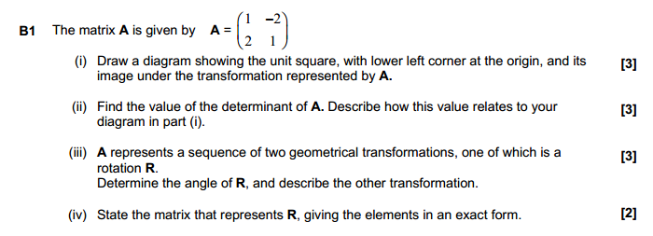
6)

7)
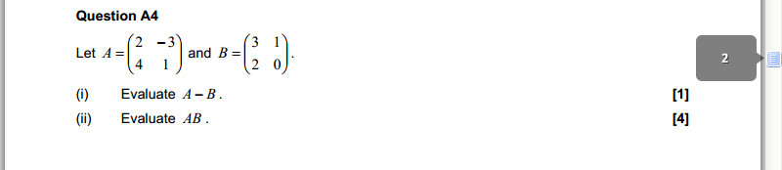

8)
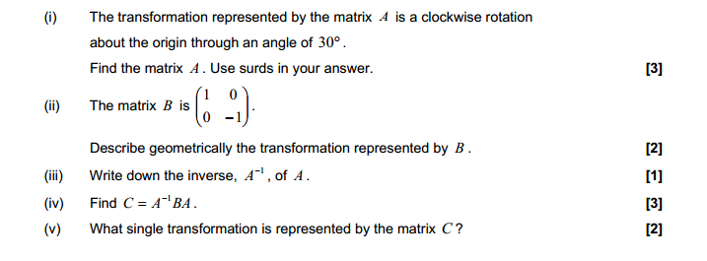

9)
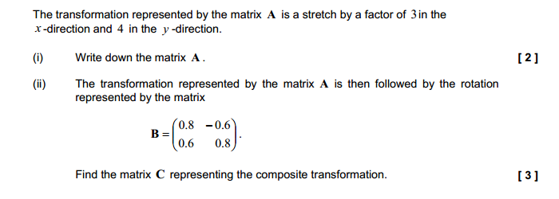

ANSWERS
1)

a)
so x= 3 and y = -2. [1]
b) $\left(\begin{matrix}1/{\sqrt{2}} & {−1}/{\sqrt{2}} \\ 1/{\sqrt{2}} & 1/{\sqrt{2}}\end{matrix}\right)\left(\begin{matrix}−1 & 0 \\ 0 & 1\end{matrix}\right)=\left(\begin{matrix}{−1}/{\sqrt{2}} & {−1}/{\sqrt{2}} \\ {−1}/{\sqrt{2}} & 1/{\sqrt{2}}\end{matrix}\right)$ [4]
c)
$\left(\begin{matrix}a & b \\ c & d\end{matrix}\right)=\frac{1}{4}\left(\begin{matrix}5 & 6 \\ 0 & 4\end{matrix}\right)\left(\begin{matrix}−2 & 2 \\ 3 & −1\end{matrix}\right)=\left(\begin{matrix}2 & 1 \\ 3 & −1\end{matrix}\right)$ [2]
d)
m = 1 and n = 4. [2]

e)
${\left(\begin{matrix}1 & 2 & 3 \\ 1 & 1 & 2 \\ 1 & 1 & 0\end{matrix}\right)}^{−1}=\frac{1}{2}{\left(\begin{matrix}−2 & 2 & 0 \\ 3 & −3 & 1 \\ 1 & 1 & −1\end{matrix}\right)}^{T}=\frac{1}{2}\left(\begin{matrix}−2 & 3 & 1 \\ 2 & −3 & 1 \\ 0 & 1 & −1\end{matrix}\right)$ [2]

2)
2
a) $A=\left(\begin{matrix}3 & 7 \\ 2 & 4\end{matrix}\right)$ $A^{t}=\left(\begin{matrix}3 & 2 \\ 7 & 4\end{matrix}\right)$ [1]
$B=\left(\begin{matrix}1 & −2 \\ 3 & 5\end{matrix}\right)$ $\text{det}B=1\text{.}5−(−2)3=\text{11}$ [1]
$\text{AB}=\left(\begin{matrix}3 & 7 \\ 2 & 4\end{matrix}\right)\left(\begin{matrix}1 & −2 \\ 3 & 5\end{matrix}\right)=\left(\begin{matrix}3+\text{21} & −6+\text{35} \\ 2+\text{12} & −4+\text{20}\end{matrix}\right)=\left(\begin{matrix}\text{24} & \text{29} \\ \text{14} & \text{16}\end{matrix}\right)$ [1]
$B^{−1}=\frac{1}{\text{det}B}\left(\begin{matrix}5 & 2 \\ −3 & 1\end{matrix}\right)=\frac{1}{\text{11}}\left(\begin{matrix}5 & 2 \\ −3 & 1\end{matrix}\right)$ [2]
- reflection in x is $\left(\begin{matrix}1 & 0 \\ 0 & −1\end{matrix}\right)$ [1]
rotation is $\left(\begin{matrix}\text{cos}θ & −\text{sin}θ \\ \text{sin}θ & \text{cos}θ\end{matrix}\right)$ [1]
rotation then reflection is
$\left(\begin{matrix}1 & 0 \\ 0 & −1\end{matrix}\right)$$\left(\begin{matrix}\text{cos}θ & −\text{sin}θ \\ \text{sin}θ & \text{cos}θ\end{matrix}\right)$=$\left(\begin{matrix}\text{cos}θ & −\text{sin}θ \\ −\text{sin}θ & −\text{cos}θ\end{matrix}\right)=\left(\begin{matrix}\text{cos}θ & −\text{sin}θ \\ −\text{sin}θ & \text{cos}θ\end{matrix}\right)$ [1+1]
c)

$=\frac{1}{8}\left(\begin{matrix}4 & 8 & −2 \\ −\text{10} & 2 & 1 \\ −2 & −2 & 1\end{matrix}\right)$. [2]

3)

A2) ${\left[\begin{matrix}−3 & −7 \\ 1 & 2\end{matrix}\right]}^{2}=\left[\begin{matrix}2 & 7 \\ −1 & −3\end{matrix}\right]$ M2
${\left[\begin{matrix}−3 & −7 \\ 1 & 2\end{matrix}\right]}^{3}={\left[\begin{matrix}−3 & −7 \\ 1 & 2\end{matrix}\right]}^{2}\left[\begin{matrix}−3 & −7 \\ 1 & 2\end{matrix}\right]=\left[\begin{matrix}2 & 7 \\ −1 & 3\end{matrix}\right]\left[\begin{matrix}−3 & −7 \\ 1 & 2\end{matrix}\right]=\left[\begin{matrix}1 & 0 \\ 0 & 1\end{matrix}\right]$ M2,A1

4)
$\left[\begin{matrix}x \\ y\end{matrix}\right]={\left[\begin{matrix}1 & −2 \\ 2 & 4\end{matrix}\right]}^{−1}\left[\begin{matrix}5 \\ 2\end{matrix}\right]=\frac{1}{8}\left[\begin{matrix}4 & 2 \\ −2 & 1\end{matrix}\right]\left[\begin{matrix}5 \\ 2\end{matrix}\right]=\left[\begin{matrix}3 \\ −1\end{matrix}\right]$ M1,A1
b) Original triangle has area 1. (A sketch will help.) M1
Transformed area $=\left|\begin{matrix}3 & 2 \\ 2 & 5\end{matrix}\right|×$original area
$=\left|\begin{matrix}3 & 2 \\ 2 & 5\end{matrix}\right|×1$
$=3\text{.}5−2\text{.}2=\text{11}$ M1,A2
c)
$b=G=\left|\begin{matrix}3 & 2 \\ 0 & −1\end{matrix}\right|=−3$ A1
d) $\left|\begin{matrix}1 & 3 & c \\ 2 & 0 & −1 \\ 1 & 1 & 0\end{matrix}\right|=1\left|\begin{matrix}0 & −1 \\ 1 & 0\end{matrix}\right|−3\left|\begin{matrix}2 & −1 \\ 1 & 0\end{matrix}\right|+c\left|\begin{matrix}2 & 0 \\ 1 & 1\end{matrix}\right|$ M1
$=1−3(1)+c(2)=0$ M1
$c=1$. A1

5)

