Maclaurins series sem 1

1)
a) Show that the first three non zero terms of the Maclaurin’s series for sinθ give $\text{sin}θ≈θ−\frac{θ^{3}}{3!}+\frac{θ^{5}}{5!}−\text{.}\text{.}\text{.}$

b) Using the result from a), find sin(18º) correct to 5 sig.fig.

c) The Maclaurin’s series for sinhx is $\text{sinh}x≈x+\frac{x^{3}}{3!}+\frac{x^{5}}{5!}+\text{.}\text{.}\text{.}$.By replacing x by ix, find a relation between sinx, sinhix and i.

2)
a) Show that the Maclaurin’s series for cosx is:
$\text{cos}x=1−\frac{x^{2}}{2!}+\frac{x^{4}}{4!}−\frac{x^{6}}{6!}+\text{.}\text{.}\text{.}$

b) Given that $\text{cos}x\text{.}\text{sec}x=1$ can be written as:
$(1−\frac{x^{2}}{2!}+\frac{x^{4}}{4!}−\frac{x^{6}}{6!}+\text{.}\text{.}\text{.})(a+{\text{bx}}^{2}+{\text{cx}}^{4}+{\text{dx}}^{6}+\text{.}\text{.}\text{.})=1+(0x^{2}+0x^{4}+0x^{6}+\text{.}\text{.}\text{.})$,
find the values of a, b, c and d and hence find the first four non-zero terms of the Maclaurin’s series of secx.

3)
a) Show that the Maclaurin’s series for $\text{cos}x$ is given by $\text{cos}x=1−\frac{x^{2}}{2!}+\frac{x^{4}}{4!}−\text{.}\text{.}\text{.}$.

b) Show that the Maclaurin’s series for $e^{x}$ is given by $e^{x}=1+x+\frac{x^{2}}{2!}+\frac{x^{3}}{3!}+\text{.}\text{.}\text{.}$

c) By multiplying results from a) and b), calculate the Maclaurin’s series for $e^{x}\text{cos}x$up to the term in x³.
d) Using the formula $f(x)=f(0)+\text{xf}'(0)+\frac{x^{2}}{2!}f\text{ \backslash ( 0 \backslash ) + }. . .\text{ \} \{}$, calculate the Maclaurin’s series for $e^{x}\text{cos}x$up to the term in x³.

4)
a) Show that the Maclaurin’s series for $\text{cosh}x$ is given by $\text{cosh}x=1+\frac{x^{2}}{2!}+\frac{x^{4}}{4!}+\frac{x^{6}}{6!}+\text{.}\text{.}\text{.}$ in terms up to $x^{6}$.

b) By replacing $x$ by $\text{ix}$ in the Maclaurin’s series for $\text{cosh}x$, find the Maclaurin’s series for $\text{cosh}\text{ix}$ in terms up to $x^{6}$.

c) Hence show that $\text{cos}x=\text{cosh}\text{ix}$.
d) Use the Maclaurin’s series for $\text{cosh}x$ to find $\text{cosh}0\text{.}2$ correct to 6d.p.

BONUS
A particle P of mass 5kg rests on a rough inclined plane of angle arcsin（3/5） The coefficient of friction between P and the plane is 1/8。 P is connected to a particle Q of mass 4kg by a light inextensible string which lies along a line of greatest slope of the plane and passes over a smooth fixed pulley at thｅ top of the plane。 Q is hanging freely 2m above a horizontal plane。 The system is released from rest with the string taut。 Assuming P does not reach the pulley find （a） the acceleration of the system （b） the time that elapses before Q hits the horizontal plane （c） the total distance P moves up the plane。
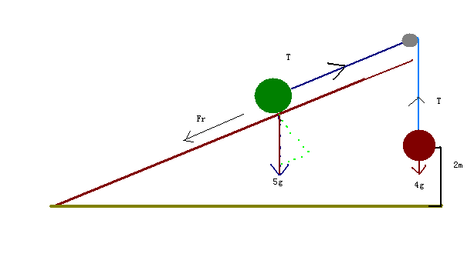

Answers
1)a)
$\text{sin}(θ)=θ−\frac{θ^{3}}{3!}+\frac{θ^{5}}{5!}−\text{.}\text{.}\text{.}$ [1]
b) ${\text{18}}^{o}=π/{\text{10}}$ [1]
= 0.309016985 = 0.30902 (5 sig.fig.) [1]
c) $\text{sinh}x=x+\frac{x^{3}}{3!}+\frac{x^{5}}{5!}+\frac{x^{7}}{7!}+$

$\text{sinh}(\text{ix})=i\text{sin}x$. [2]

3)
a)
M1
So $\text{cos}x=1−{x^{2}}/2!+{x^{4}}/4!−\text{.}\text{.}$

b) $f(x)=f(0)+\text{xf}'(0)+x2/2!f\text{ \backslash ( 0 \backslash ) + }. . .\text{ \} \{}$
So $e^{x}=1+x+{x^{2}}/2!+\text{.}\text{.}\text{.}$
c) $e^{x}\text{cos}x=(1+x+{x^{2}}/2+{x^{3}}/6)(1−{x^{2}}/2+{x^{4}}/4!−\text{.}\text{.}\text{.})$
$e^{x}\text{cos}x=1+x−{x^{3}}/3$. M1,A1

d)
$f(x)=1+x−{x^{3}}/3$ as above. A1

4)
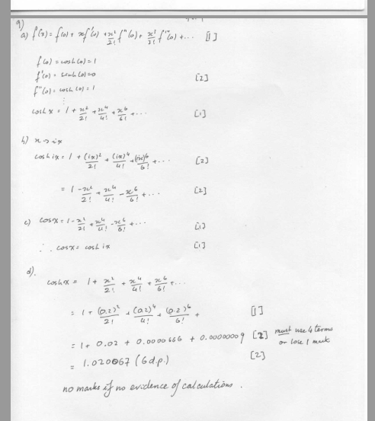

BONUS
a） T- 5gsin（ø） - Fr = 5a
4g- T= 4a

T- 5g（3/5） - μ5g cos（ø） = 5a
4g- T= 4a

T- 5g（3/5） - （1/8）5g （4/5） = 5a
T = 5a +3g +（1/2）g
T = 5a +（7/2）g

4g- [5a +（7/2）g ]= 4a
4g- （7/2）g = 9a
（8/2）g- （7/2）g = 9a
g= 18a
a=g/18

b）S = ut +１／２ａｔ^{２}
２ = １／２（ｇ／１8）ｔ^{２}
36 = ｔ^{２}
ｔ＝6ｓ

ｃ）
Ｓ ＝ ut +１／２ａｔ^{２}
Ｓ ＝ １／２（ｇ／１8）（6）^{２}
Ｓ ＝ ｇ

