Hyperbolic functions
1)

a) Solve the equation sinhx + 3coshx = 5, giving your answer in logarithmic (ln) form. [6]
b) Solve the equation sinhx + 3 cosh²x = 5. giving your answers correct to 3 significant figures. [4]
c) Show that ${\text{tanh}}^{−1}x=\frac{1}{2}\text{ln}\left(\frac{1+x}{1−x}\right)$. [5]

2)
a) By expanding ${\left(\frac{e^{x}+e^{−x}}{2}\right)}^{3}$, show that $\text{cosh}3x=A{\text{cosh}}^{3}x+B\text{cosh}x$ where A and B are to be found. [4]
b) Solve $\text{12}{\text{cosh}}^{2}x+7\text{sinh}x=\text{24}$, giving your answers correct to 3dp [5]
c) Solve $3\text{sinh}x−\text{cosh}x=1$, giving your answer in exact form. [5]
d) Given that ${\text{cosh}}^{−1}x=\text{ln}(x+\sqrt{x^{2}−1})$ or ${\text{cosh}}^{−1}x=\text{ln}(x−\sqrt{x^{2}−1})$, state the value of $\text{ln}(x+\sqrt{x^{2}−1})+\text{ln}(x−\sqrt{x^{2}−1})$. (A sketch will help.) [1]

3)
Solve $3{\text{cosh}}^{2}x+\text{sinh}x=6$, giving your answers to 3 decimal places. [5]

4)
a) Solve the equation ${\text{sinh}}^{2}x−2\text{cosh}x=2$, leaving your answer in exact form. [6]
b) Show that $\text{cosh}x−\text{sec}\text{hx}=\text{sinh}x\text{tanh}x$. [3]
c) Given $\text{sinh}x=\left(\frac{e^{x}+e^{−x}}{2}\right)$, show that $\text{sinh}3x=4{\text{sinh}}^{3}x+3\text{sinh}x$.
By comparing $\text{sinh}3x=4{\text{sinh}}^{3}x+3\text{sinh}x$ with the equation $5=4x^{3}+3x$, find a solution to the latter correct to 3 significant figures.

5)
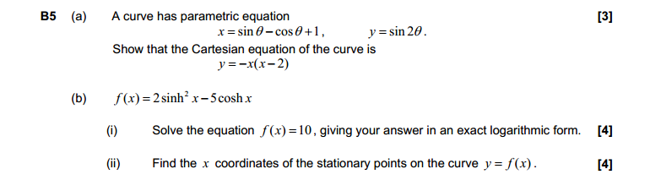

6)
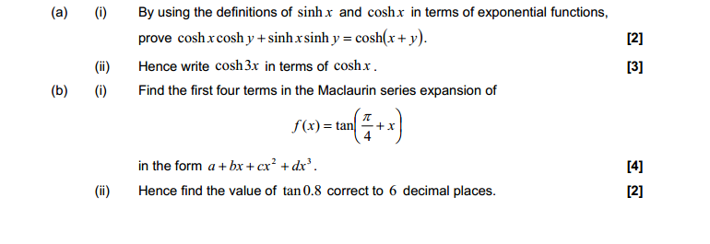

7)
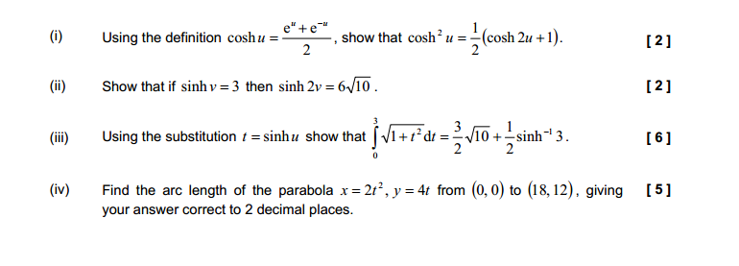

Answers

1)
a) $\text{sinh}+3\text{cosh}x=5$
$\frac{e^{x}−e^{−x}}{2}+3\frac{e^{x}+e^{−x}}{2}=5$ [1]
$e^{x}+e^{−x}+3e^{x}+3e^{−x}=\text{10}$
$4e^{x}+2e^{−x}−\text{10}=0$
$2e^{x}+e^{−x}−5=0$
$2e^{2x}−5e^{x}+1=0$ [2]
$e^{x}=\frac{5±\sqrt{5^{2}−8}}{4}=\frac{5±\sqrt{\text{17}}}{4}$ [1]
$x=\text{ln}\left(\frac{5±\sqrt{\text{17}}}{4}\right)$. [2]
b) $\text{sinh}x+3{\text{cosh}}^{2}x=5$
$\text{sinh}x+3(1+{\text{sinh}}^{2}x)=5$ [1]
$3{\text{sinh}}^{2}x=\text{sinh}x−2=0$
$\text{sinh}x=\frac{−1±\sqrt{1+4\text{.}3\text{.}2}}{3\text{.}2}=\frac{−1±\sqrt{\text{25}}}{6}=\frac{−1±5}{6}$ [1]
$\text{sinh}x=−1,x={\text{sinh}}^{−1}(−1)=−0\text{.}\text{881}$ (3 sig.fig). [1]
$\text{sinh}x=(2/3),x={\text{sinh}}^{−1}(2/3)=0\text{.}\text{625}$ (3 sig.fig). [1]
c) $y={\text{tanh}}^{−1}x$
$x=\text{tanh}y=\frac{\text{sinh}y}{\text{cosh}y}=\frac{(1/2)(e^{y}−e^{−y})}{(1/2)(e^{y}+e^{−y})}$ [1]
$x=\frac{e^{2y}−1}{e^{2y}+1}$ [1]
$e^{2y}x+x=e^{2y}−1$
$e^{2y}=\frac{1+x}{1−x}$ [1]
$y=\frac{1}{2}\text{ln}\left(\frac{1+x}{1−x}\right)$ [1]
${\text{tanh}}^{−1}x=\frac{1}{2}\text{ln}\left(\frac{1+x}{1−x}\right)$. [1]

2)
a) ${\text{cosh}}^{3}x={\left(\frac{e^{x}+e^{−x}}{2}\right)}^{3}={\left(\frac{e^{x}+e^{−x}}{2}\right)}^{2}\left(\frac{e^{x}+e^{−x}}{2}\right)$ [1]
$=\left(\frac{e^{2x}+2+e^{−2x}}{4}\right)\left(\frac{e^{x}+e^{−x}}{2}\right)$
$=\frac{1}{8}\left(e^{3x}+e^{−3x}+3e^{x}+3e^{−x}\right)$ [1]
$$=\frac{1}{4}\left(\frac{e^{3x}+e^{−3x}}{2}+3\frac{e^{x}+e^{−x}}{2}\right)$$
${\text{cosh}}^{3}x=\frac{1}{4}\text{cosh}3x+\frac{3}{4}\text{cosh}x$ [1]
$\text{cosh}3x=4{\text{cosh}}^{3}x−3\text{cosh}x$ [1]
A = 4, B = -3
b) $\text{12}{\text{cosh}}^{2}x+7\text{sinh}x=\text{24}$
$\text{12}\left(1+{\text{sinh}}^{2}x\right)+7\text{sinh}x=\text{24}$ [1]
$\text{12}{\text{sinh}}^{2}x+7\text{sinh}x−\text{12}=0$ [1]
$$\text{sinh}x=\frac{−7±\sqrt{\text{72}+4×\text{12}×\text{12}}}{\text{24}}$$
$=\frac{−7±\text{25}}{\text{24}}={−4}/3\text{or}3/4$ [1]
$x={\text{sinh}}^{−1}(−4/3)=$ -1.10 (3 sig.fig.) [1]
$x={\text{sinh}}^{−1}(3/4)=$ 0.693 (3 sig.fig.) [1]
c) $3\text{sinh}x−\text{cosh}x=1$
$3\left(\frac{e^{x}−e^{−x}}{2}\right)−\left(\frac{e^{x}+e^{−x}}{2}\right)=1$ [1]
$$3e^{x}−3e^{−x}−e^{x}−e^{−x}=2$$
$2e^{x}−4e^{−x}−2=0$ [1]
$$e^{x}−2e^{−x}−1=0$$
$e^{2x}−2−e^{x}=0$
$e^{2x}−e^{x}−2=0$ [1]
$$e^{x}=\frac{1±\sqrt{1+4}}{2}=\frac{1±\sqrt{5}}{2}$$
$x=\text{ln}\left(\frac{1±\sqrt{5}}{2}\right)$ [2]
d) 0 (zero) [1]

3)
$$3{\text{cosh}}^{2}x+\text{sinh}x=6$$
$3({\text{sinh}}^{2}x+1)+\text{sinh}x=6$ M1
$3{\text{sinh}}^{2}x+\text{sinh}x−3=0$
$\text{sinh}x=\frac{−1±\sqrt{1+4\text{.}3\text{.}3}}{6}=\frac{−1±\sqrt{\text{37}}}{6}$ M1
$\text{sinh}x=\frac{−1+\sqrt{\text{37}}}{6}$ gives $x=0\text{.}\text{769}(3d\text{.}p\text{.})$. M1,A1
$\text{sinh}x=\frac{−1−\sqrt{\text{37}}}{6}$ gives $x=−1\text{.}\text{003}(3d\text{.}p\text{.})$. M1

4)

