COMPLEX NUMBERS QUESTIONS

1)
a) Find the complex roots of the equation y = 2x² + 3x + 2. [3]
b) Given that 1, ω and ω² are the cube roots of 1, find
1 + ω² + ω⁴ + ω⁶ + ω⁸ + ω¹⁰. [3]
c) Find the cartesian form of the locus defined by |z + 2 - 3i| = |z -1 + i|.
[4]
d) Find the cartesian form of the locus defined by arg(z - 1 - 2i) = 3π/4.
[4]
e) Find the square roots of 5 - 12i.

2)
a) If $z_{1}=x_{1}+{\text{iy}}_{1}$ and $z_{2}=x_{2}+{\text{iy}}_{2}$ show that $z_{1}∗\text{.}z_{2}∗(z_{1}\text{.}z_{2})∗$, where the star (*) indicates complex conjugate. [3]
b) Find the complex roots of $x^{2}−6x+\text{13}=0$. [3]
c) Find the Cartesian form of $|z−5+2i|=5$. [4]
d) Find the Cartesian form of $|z+6|=|z−2+6i|$. [5]
e) How many points of intersection are there between c) and d)? [2]
f) Find the modulus and argument of $z=−3−2i$. [3]

3) Given the complex numbers $z_{1}=3+2i$ and $z_{2}=4−i$, find $\frac{z_{1}}{z_{1}+z_{2}}$ in the form $a+\text{bi}$. [5]

4)
1)
a) Solve the quadratic equation $z^{2}−4z+5=0$. [3]
b) The cube roots of unity (1) are 1, $ω$ and $ω^{2}$.
i) State the value of $1+ω+ω^{2}$. [1]
ii) Find the value of $\frac{1}{ω^{6}}+\frac{1}{ω^{5}}+\frac{1}{ω^{4}}+\frac{1}{ω^{3}}+\frac{1}{ω^{2}}+\frac{1}{ω}$. [1]
c) Write down the Cartesian (x,y) form of the locus given by $|z−(3−4i)|=3$. [2]
d) i) Find the square roots of $−3−4i$. [5]
ii) Using your answer to i) and the quadratic formula, solve the equation $z^{2}−5z+(7+i)=0$. [3]

5)
a) Solve the equation $x^{2}−6x+\text{10}=0$. [3]
b) The cube roots of unity are 1, $ω$ and $ω^{2}$. Evaluate $ω^{2}+ω^{4}+ω^{6}+ω^{8}+ω^{\text{10}}+ω^{\text{12}}$. [3]
c) Given $z_{1}=2+i$ and $z_{2}=3+i$, calculate $z_{1}z_{2}$, $\text{arg}\left(z_{1}\right)$, $\text{arg}\left(z_{2}\right)$ and $\text{arg}\left(z_{1}z_{2}\right)$.
Hence show that $\frac{π}{4}={\text{tan}}^{−1}\left(\frac{1}{2}\right)+{\text{tan}}^{−1}\left(\frac{1}{3}\right)$. [5]
d) Does the point $5+i$ lie inside or outside the circle $|z−3+2i|=4$. [4]
e) Find the square roots of $7+\text{24}i$. [5]
6)

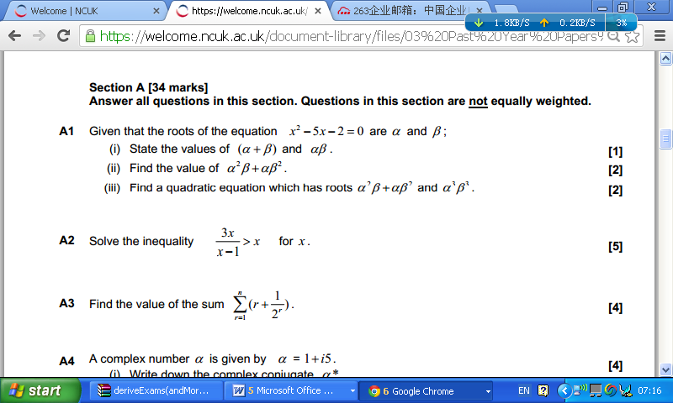

7)

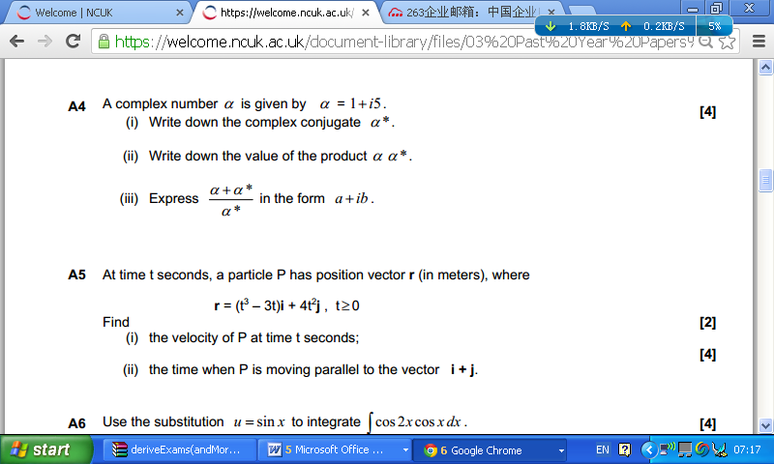

8)
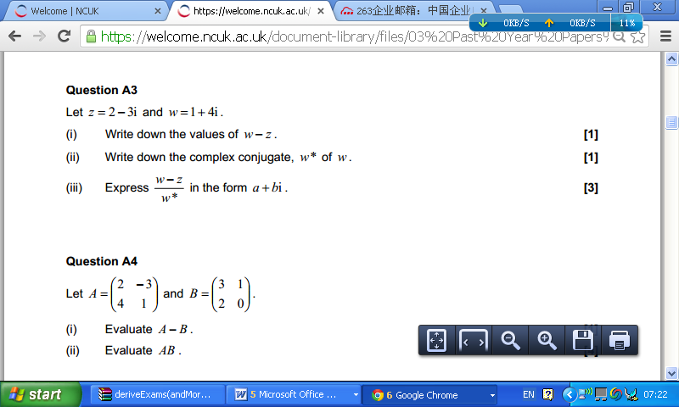

9)
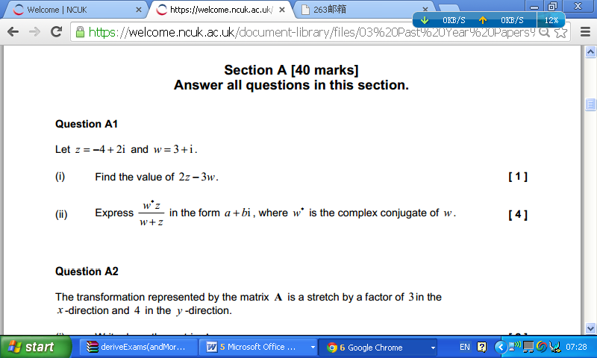

10)

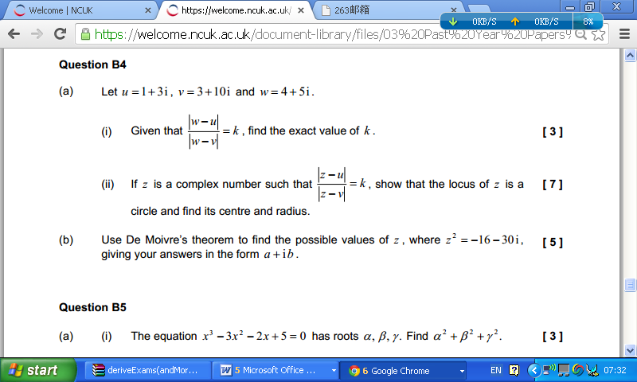

11)
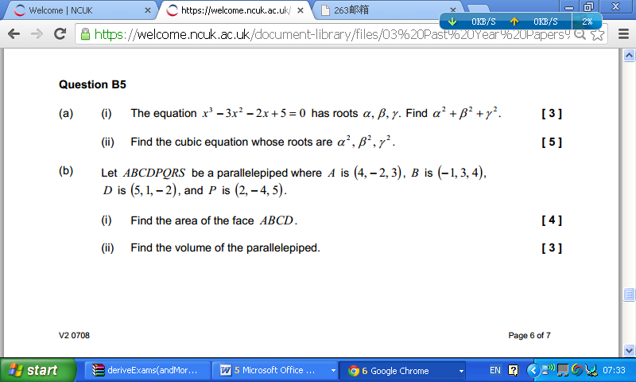

1)a) y = 2x² + 3x + 2 = 0
$x=\frac{−3±\sqrt{3^{2}−4\text{.}2\text{.}2}}{2\text{.}2}$ [1]
$x=\frac{−3±\sqrt{−7}}{4}$
$x=\frac{−3±\sqrt{7}i}{4}$. [2]
b) 1 + ω² + ω⁴ + ω⁶ + ω⁸ + ω¹⁰
ω³ = ω⁶ = ω⁹ = 1, so
= 1 + ω² + ω + 1 + ω² + ω [1]
1 + ω + ω² = 0, so
= 0. [2]
c) |z + 2 - 3i| = |z - 1 + 1|
|(x + 2) + (y - 3)i| = |(x - 1) + (y + 1)i|
(x + 2)² + (y - 3)² = (x - 1)² + (y + 1)²
x² + 4x + 4 + y² - 6y + 9 = x² - 2x + 1 + y² + 2y + 1 [2]
4x - 6y + 13 = -2x + 2y + 2
6x - 8y + 11 = 0 or $y=\frac{6x+\text{11}}{8}$. [2]
Alternative method.
Locus is the perpendicular bisector of (-2,3) and (1,-1)
Midpoint is (-1/2,1) [1]
Gradient is (3 - (-1))/(-2 -1) = -4/3
Gradient of bisector is 3/4 [1]
Point gradient line is y - y₁ = m(x - x₁)
y - 1 = 3/4(x - (-1/2)) = 3/4(x + 1/2)
y = 3/4(x +1/2) + 1,
$y=\frac{6x+\text{11}}{8}$. [2]
d) arg(z - 1 - 2i) = 3π/4
arg(x - 1 + (y - 2)i) = 3π/4
${\text{tan}}^{−1}\left(\frac{y−2}{x−1}\right)=\frac{3π}{4}$
$\left(\frac{y−2}{x−1}\right)=−1$ [2]
y = 3 - x ; x < 1. [2]
Alternative method.
Locus is the half line originating at (1,2) with gradient -1.
This has intercept with the y axis of y = 3,
so y = 3 - x ; x < 1.

e) $\sqrt{5−\text{12}i}$ = a + bi
5 - 12i = a² - b² + 2abi
5 = a² - b² and -6 = ab [1] + {1]
a = -6/b, a² = 36/b²
5 = 36/b² - b²
5b² = 36 - b⁴
b⁴ + 5b² - 36 = 0
(b² - 4)(b² + 9) = 0 [1]
b = $±2$, a = -/+3.
$\sqrt{5−\text{12}i}=±(3−2i)$. [3]

2)
a) $z_{1}=x_{1}+{\text{iy}}_{1}$, $z_{2}=x_{2}+{\text{iy}}_{2}$, $z_{1}^{}=x_{1}−{\text{iy}}_{1}$, $z_{2}^{}=x_{2}−{\text{iy}}_{2}$.
$$z_{1}^{}z_{2}^{}=(x_{1}−{\text{iy}}_{1})(x_{2}−{\text{iy}}_{2})=x_{1}x_{1}−i(x_{1}y_{2}+x_{2}y_{1})+i^{2}y_{1}y_{2}$$
$z_{1}^{}z_{2}^{}=x_{1}x_{1}−y_{1}y_{2}−i(x_{1}y_{2}+x_{2}y_{1})$ [1]
$$z_{1}z_{2}=(x_{1}+{\text{iy}}_{1})(x_{2}+{\text{iy}}_{2})=x_{1}x_{1}+i(x_{1}y_{2}+x_{2}y_{1})+i^{2}y_{1}y_{2}$$
$z_{1}z_{2}=x_{1}x_{1}−y_{1}y_{2}+i(x_{1}y_{2}+x_{2}y_{1})$ [1]
$(z_{1}z_{2})^{}=x_{1}x_{1}−y_{1}y_{2}−i(x_{1}y_{2}+x_{2}y_{1})=z_{1}^{}z_{2}^{}\text{.}$ [1]
b) $x^{2}−6x+\text{13}=0$ OR
$(x−3)^{2}+4=0$ [1] $x=\frac{6±\sqrt{6^{2}−4\text{.}\text{13}}}{2}$ [1]
$(x−3)^{2}=−4$ $=\frac{6±\sqrt{\text{36}−\text{52}}}{2}$
$x−3=±2i$ [1] $=\frac{6±\sqrt{−\text{16}}}{2}$ [1]
$x=3±2i$ [1] $=\frac{6±4i}{2}$=$3±2i$ [1]

c) $|z−5+2i|=5$
$|x+\text{iy}−5+2i|=5$ [1]
$|x−5+i(y+2)|=5$ [1]
$(x−5)^{2}+(y+2)^{2}=5^{2}=\text{25}$ [2]
d) $|z+6|=|z−2+6i|$
$|x+\text{iy}+6|=|x+\text{iy}−2+6i|$ [1]
$$|x+6+\text{iy}|=|x−2+i(y+6)|$$
$(x+6)^{2}+y^{2}=(x−2)^{2}+(y+6)^{2}$ [1]
$x^{2}+\text{12}x+\text{36}+y^{2}=x^{2}−4x+4+y^{2}+\text{12}y+\text{36}$ [1]
$$\text{12}x=−4x+4+\text{12}y$$
$$\text{12}y−\text{16}x+4=0$$
$3y−4x+1=0$ [2]
$y=4x/3−1/3$ OR [2]
OR locus is perpendicular bisector of (-6,0) and (2,-6)
gradient of line between these two points is $m=\frac{−6−0}{2−(−6)}={−3}/4$
gradient of perpendicular bisector is 4/3 [1]
midpoint of two points is (-2,-3) [1]
equation of perpendicular bisector is $y−y_{1}=m(x−x_{1})$
$y+3=(4/3)(x+2)=4x/3+8/3$ [1]
$y=4x/3−1/3$ [2]
e) number of points of intersection
substitute $y=4x/3−1/3$ from d) into $(x−5)^{2}+(y+2)^{2}=5^{2}=\text{25}$ from c).
$y=\frac{4x−1}{3}$ $y+2=\frac{4x−1}{3}+\frac{6}{3}=\frac{4x+5}{3}$
$(x−5)^{2}+(\frac{4x+5}{3})^{2}=5^{2}$ [1]
$$9(x−5)^{2}+(4x+5)^{2}=9\text{.}5^{2}$$
$$9(x^{2}−\text{10}x+5^{2})+\text{16}x^{2}+\text{40}x+5^{2}−9\text{.}5^{2}=0$$
$$\text{25}x^{2}−\text{50}x+5^{2}=0$$
$$x^{2}−2x+1=0$$
$$(x−1)^{2}=0$$
$x=1$ repeated root implies 1 point of intersection (tangent) [1]

f) $z=−3−2i$
modulus $|z|=\sqrt{3^{2}+2^{2}}=\sqrt{\text{13}}$ [1]
argument
$θ=−\text{180}+{\text{tan}}^{−1}(2/3)=−{\text{146}}^{o}$(3sig.fig.) [1+1]

3)
$\frac{z_{1}}{z_{1}+z_{2}}=\frac{3+2i}{(3+2i)+(4−i)}=\frac{3+2i}{7+i}$ M2
$=\frac{3+2i}{7+i}×\frac{7−i}{7−i}=\frac{\text{23}+\text{11}i}{\text{50}}$ M2, A1

4)
a) $z^{2}−4z+5=0$
$z=\frac{4±\sqrt{4^{2}−4×5}}{2}$ M1
$z=\frac{4±\sqrt{−4}}{2}$
$z=2±i$ A2
b) i) $1+ω+ω^{2}=0$ A1
ii) multiply 1st three terms by $ω^{6}$ and last three terms by $ω^{3}$ gives
$1+ω+ω^{2}+1+ω+ω^{2}=0$ or otherwise A1
c) $(x−3)^{2}+(y+4)^{2}=9$ A2
d) i) $\sqrt{−3−4i}=a+\text{bi}$
$−3−4i=a^{2}−b^{2}+2\text{abi}$ M1
$a^{2}−b^{2}=−3$
$2\text{ab}=−4$ M1
$a={−2}/b$
$a^{2}−b^{2}=a^{2}−(−2/b)^{2}=−3$
$b^{4}−3b^{2}−4=0$
$(b^{2}−4)(b^{2}+1)=0$ M1
$b=±2$
$a={−2}/b=∓1$
$\sqrt{−3−4i}=±(1−2i)$ A2
ii) $z^{2}−5z+(7+i)=0$
$z=\frac{5±\sqrt{(−5^{2})−4(7+i)}}{2}$ M1
$z=\frac{5±\sqrt{\text{25}−\text{28}−4i}}{2}$
$z=\frac{5±\sqrt{−3−4i}}{2}$
$z=\frac{5±(1−2i)}{2}$
$z=\frac{6−2i}{2}=3−i$ A1
$z=\frac{4+2i}{2}=2+i$ A1

5)

